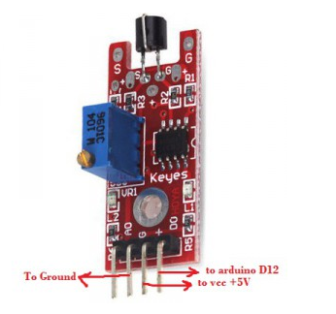
This project is to test touch sensor. When the metal head in the module is touched, the LED will turn on, otherwise it will turn off.
Step 1: connect the sensor to Arduino as per following circuit graph.
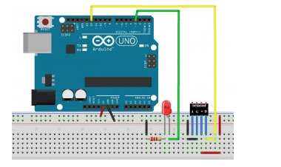
Step 2:Download sample code and load it into Arduino IDE.
Step 3: touch the metal head in the sensor, the LED will turn on.

